**PROJECT TITLE:**

**Hollow-tag( 3rd molar cut) using Work- Fusion**

1. Firstly, user has to check whether the hollow tag folder exists on desktop or not. Folder must consist of two different .xlsx documents. User has to open hollow_tag.xlsx file
2. User has to make entry in hollow_tag.xlsx file.

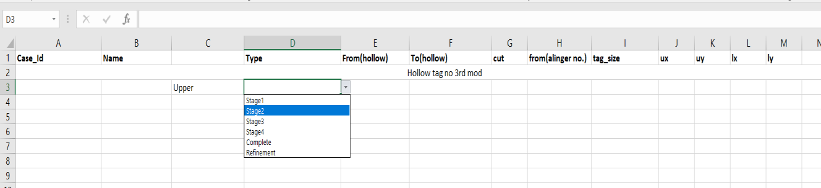

1. Entries of excel sheet are starting from A16. Case-id of patient is filled in A column. The case-id should be numeric with ten digits.
2. User must follow the following protocol to make appropriate entries in excel sheet.
   1. The initials of name are filled in column B. Suppose a person is having the name Virat Gupta then entry of column is written as VG_. If there is no surname of person then first two letters of name are taken. For same name Virat entry should be like this Vi_.
   2. Column C defines the arch whether we have to perform action on upper arch, lower arch or both. Drop down option is available to specify the arch.
   3. Column D defines the type of stage. We have total six stages (stage1, stage2, stage3, stage4, complete and refinement). It is also selected by drop down feature.
   4. Column E and F defines the starting and ending of sub steps. From which sub step we have to start hollowing our model and to which model we have to stop it.
   5. Column G defines the base cut size, which is cut in 3-D builder.
   6. Column H defines the aligner number. It is not necessary that aligner no. and sub step no. will match. That’s why we have to define them separately. Column I defines the tag size.
   7. Column J, K, L, M define the coordinates of tag. User can check the coordinates using a desktop app **Mouse-position-32 bit**. User can found this app on desktop. ux defines the upper arch x coordinate and uy defines the upper arch y coordinate. lx defines the lower arch x coordinate and ly defines lower arch y coordinate.
3. After filling the entries user must save the file and launch the work-fusion application or you can run the application from right taskbar.

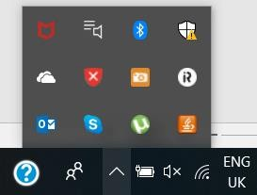

1. After launching application user have to open script file to play recording. It may appear on screen or not. So user must go to window->show view>other.

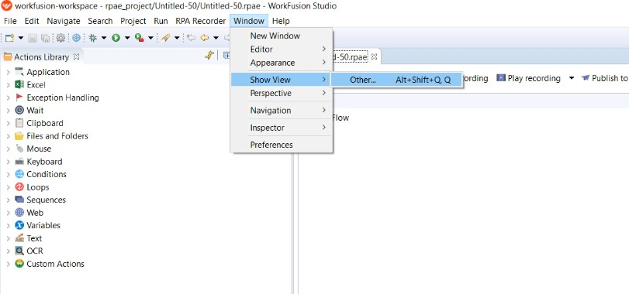

1. A dialog box will appear on the screen. Click on the media files and open it. Media files will be opened in the left side corner.

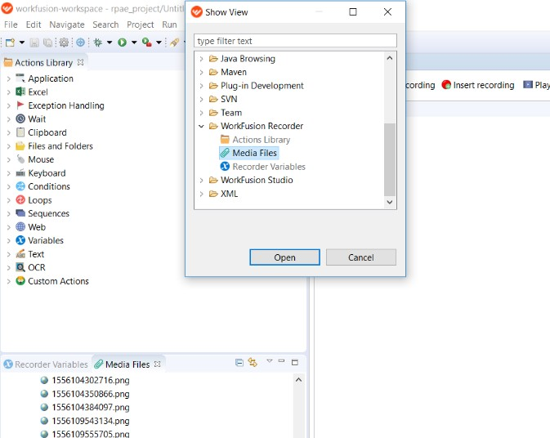

1. Double click on the **hollowtag(no builder & 3rd molar cut)** folder. Then click on the **hollowtag(no builder & 3rd molar cut)**.rpae . The file will load on right side.

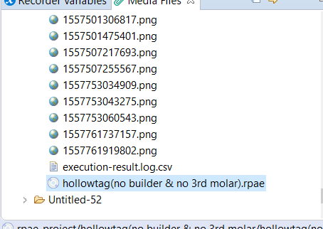

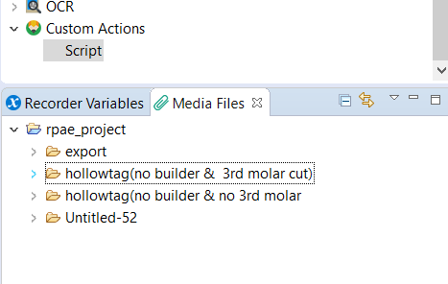

1. Click on the play recording to run the file. After we run the file a small window appears on the right side window.

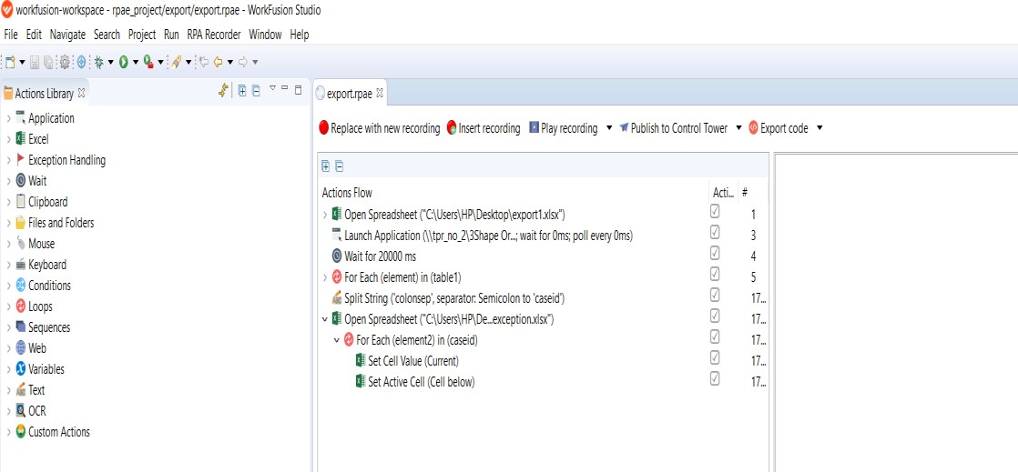

1. The window that appears on the right side must be shifted in upward direction to some extent.

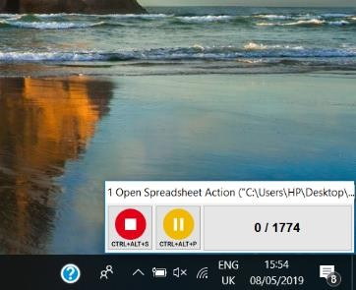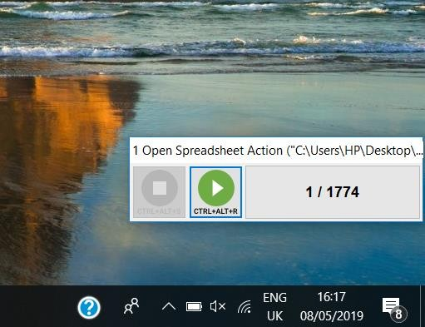

1. Sometimes it may execute an error like couldn’t connect to bot. In that case user must restart bot manager. User must check bot manager is always running.

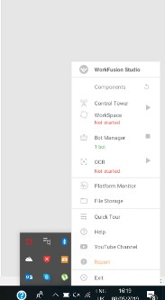

1. The names of stages must be exactly same as defined under the protocol stage.

|  |  |
| --- | --- |
| stage_1_Subsetup1 | Staging and exporting is done in both upper and lower. |
| stage_2_Subsetup2 | Staging and exporting is done in both upper and lower. |
| stage_3_Subsetup3 | Staging and exporting is done in both upper and lower. |
| stage_1_upper_Subsetup1 | Upper is staged and export. |
| stage_2_upper_Subsetup1 | Upper is staged and export. |
| stage_3_upper_Subsetup1 | Upper is staged and export. |
| stage_1_lower_Subsetup1 | Lower is staged and export. |
| stage_2_ lower_subsetup1 | Lower is staged and export. |
| stage_3_ lower_subsetup1 | Lower is staged and export. |
| upper_complete_subsetup1 | Upper is exported without staging. |
| lower_complete_subsetup1 | Lower is exported without staging. |
| complete_subsetup1 | Upper and Lower is exported without staging. |
| refinement_subsetup1 | Staging and exporting is done in both upper and lower. |
| refinement_upper_subsetup1 | Upper is staged and export. |
| refinement_lower_subsetup1 | Lower is staged and export. |
| stage_4_Subsetup1 | Staging and exporting is done in both upper and lower. |
| stage_4_upper_Subsetup1 | Upper is staged and export. |
| stage_4_lower_Subsetup1 | lower is staged and export. |